1.Write a PL/SQL program to perform banking operations using procedures

create table account(account_no number,accountholder_name varchar(20),balance number);

insert into account values(1001,'amalesh',3000);
insert into account values(1002,'devu',2000);
insert into account values(1003,'athul',4000);
insert into account values(1004,'anandhu',5000);
insert into account values(1005,'aswin',2000);

create or replace procedure withdraw(accno int,amnt int) is
begin
update account set balance=balance-amnt where account_no=accno;
end;
/

create or replace procedure deposit(accno int,amnt int) is
begin
update account set balance=balance+amnt where account_no=accno;
end;
/

create or replace procedure display is
cursor c5 is select * from account;
r c5%ROWTYPE;
begin
open c5;
loop
fetch c5 into r;
exit when c5%NOTFOUND;
dbms_output.put_line(r.account_no||' '||r.accountholder_name||' '||r.balance);
end loop;
close c5;
end;

declare
choice number;

accno int;
amnt int;
begin
accno:=&accno;
amnt:=&amnt;
dbms_output.put_line('1.deposit');
dbms_output.put_line('2.Withdraw');
choice:=&choice;
if choice=1
then
deposit(accno,amnt);
elsif choice=2
then
withdraw(accno,amnt);
else
display();
end if;
end;

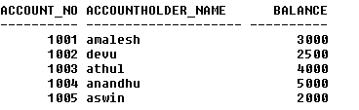

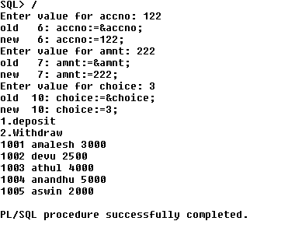

2.Selected record's price is incremented by 100, executing the procedure created & displaying the updated table(use user defined Exception)

create table product(productid int,product_name varchar(30),price int);

insert into product values(101,'usb',800);
insert into product values(102,'smart watch',2000);
insert into product values(103,'laptop',30000);
insert into product values(101,'tv',18000);

create or replace procedure error(pid int) is
invalid_pid Exception;
begin
update product set price=price+100 where productid=pid;
if sql%notfound
then
raise invalid_pid;
end if;
Exception
when invalid_pid then
dbms_output.put_line('pid not found');
dbms_output.put_line(sqlcode);
dbms_output.put_line(sqlcode);
end;



